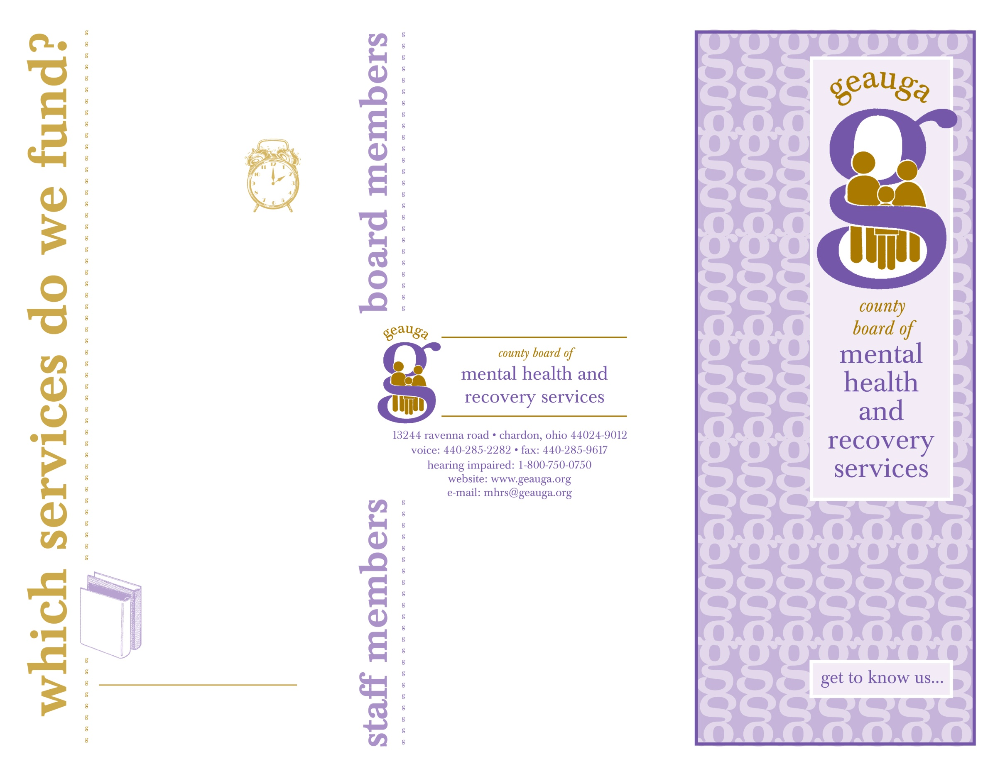

Alberta Chokshi……………....*Chair*

Ann Bagley… ……...........*Vice Chair*

Dave Welty………..……..*Treasurer*

Lisa Cavasinni………..….*Secretary*

James Holden  
 Jeffrey Kline

Carolee K. Lesyk, PhD

Nichol Mikolay  
Linda Miller  
Thomas Niewulis  
Michael Petruziello  
Daniel Schweid, M.D.  
Mary Ruth Shumway   
Leila Vidmar

James C. Adams *CEO/Executive Director*

Bethany Matthews.. Associate *Director*

James Mausser *Finance Manager*

Sandra Cohn *Information Coordinator*

Teresa Slater *Secretary/Receptionist*

A scope of services funded by the Geauga County Board of Mental Health and Recovery Services:

• EMERGENCY

SERVICES

COPELINE *~ 24 Hour*

Crisis Intervention

Medication Monitoring

Inpatient Hospitalization

• EMPLOYMENT SERVICES

Job Placement

• HOUSING

Residential Support

Residential Treatment

• OUTPATIENT SERVICES

Assessment

Counseling

Community Support

Partial Hospitalization

• PREVENTION & EDUCATION

AIDS Prevention

Big Brothers Big Sisters

Panorama Newsletter

Incredible Years

Alcohol/Drug Prevention

COPELINE: 440-285-5665

1-888-285-5665

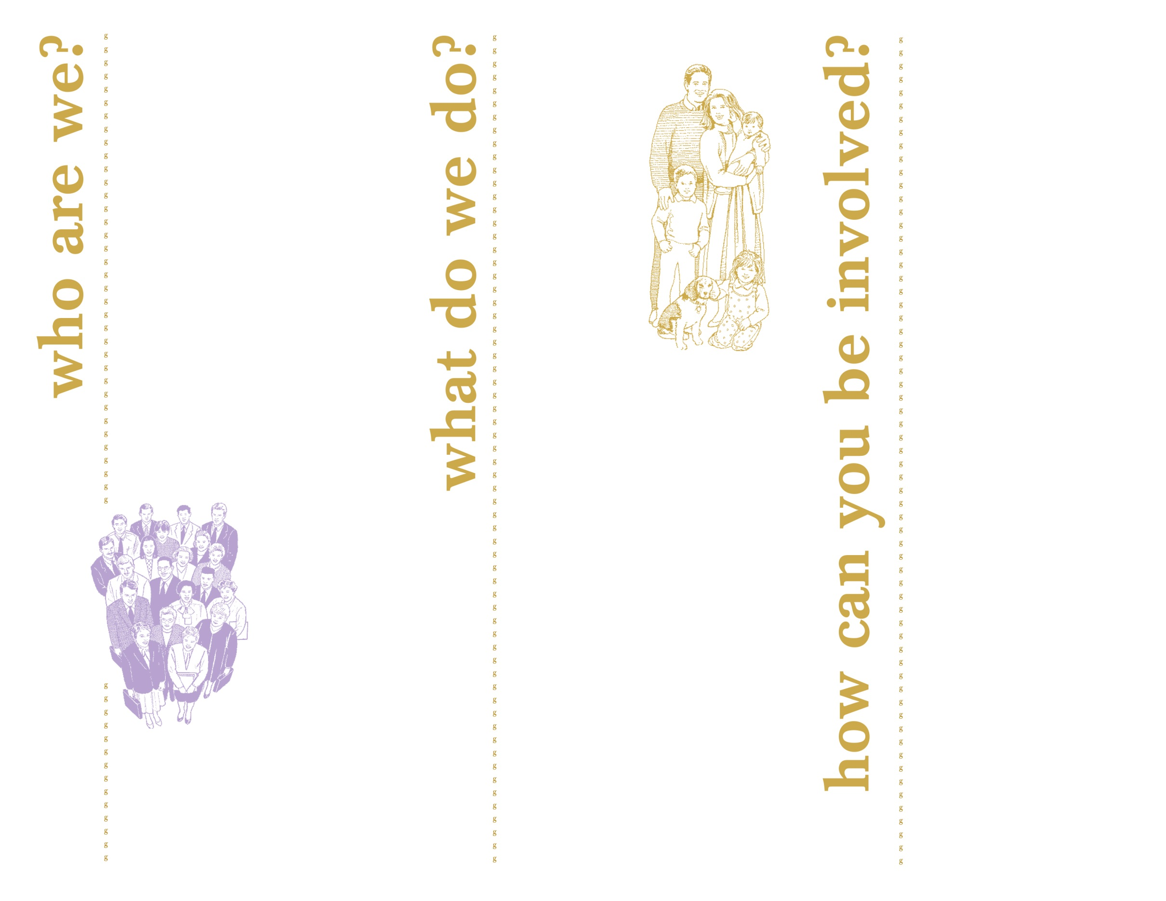

*The Geauga County Board of Mental Health and Recovery Services does not discriminate on the basis of race, color, religion, sex, national origin, ancestry, age, handicap, political affiliation and sexual orientation in its contracts, programs, activities or employment.*

The Geauga County Board of

Mental Health and Recovery

Services ensures that quality

mental health, alcohol and drug

addiction services are available to all residents of Geauga County.

* 14 volunteer members appointed by the

Ohio Department of

Mental Health and

Addiction Services

and the Geauga County Commissioners

* Established in 1968
* Governmental entity

Are you interested in mental health and substance abuse issues?

Would you like to be

involved in helping Geauga County residents receive quality care?

Would you like to find

out more about becoming a board member?

If your answer is yes,

contact the

**Geauga County**

**Board of Mental Health and Recovery Services:**

**13244 ravenna road**

**chardon, ohio 44024-9012**

voice

**440-285-2282**

hearing impaired

**1-800-750-0750**

fax

**440-285-9617**

website

**www.geauga.org**

e-mail

**mhrs@geauga.org**

The Geauga County Board of

Mental Health and

Recovery Services

is dedicated to

planning and

coordinating

a full range of

community-based

services that

provide quality

care and meet the

needs of Geauga

County residents.

In order to meet that goal,

the Board:

* Allocates funds received from Federal, State and local sources to the appropriate agencies to ensure that quality mental health and substance abuse services are provided.
* Provides education and prevention services to the community.
* Assures quality and cost effectiveness of community programs by monitoring all aspects of programs provided by the agencies.